Different formulations of Kalman Filter

* Modeling

$$x_{k}=Φ_{k}x_{k-1 }+Γ_{k}w_{k}, x_{0}\sim N\left({\overline{x}}_{0}, M_{0}\right) , w_{k}\sim N(0, W_{k}) \\ z_{k}=H_{k}x_{k}+v_{k}, v_{k}\sim N(0,V_{k})$$

And $\left(x_{0},w_{1},…w_{k}, v_{1},…,v_{k}\right) are mutually independent$

1. Two states

%% Speyer, page 97 %%

* 1. states
 $${\overline{x}}_{k}:=E\left[x_{k} | Z_{k-1}\right]$$

 $${\hat{x}}_{k}:=E[x_{k}|Z_{k}]$$

2. Prediction(priori)
 $${\overline{x}}_{k}=Φ_{k}{\hat{x}}_{k } , \\ M_{k}=Φ_{k}P_{k-1 }Φ_{k}^{T}+Γ_{k}W_{k}Γ_{k}^{T} ,$$

 3. Updating (Estimation, Posterior)
 $${\hat{x}}_{k}= {\overline{x}}_{k}+P_{k}H_{k}^{T}V_{k}^{-1}(z_{k}-H_{k}{\overline{x}}_{k}) \\ P_{k}={\left(M_{k}^{-1}+H_{k}^{T}V_{k}^{-1}H_{k}\right)}^{-1}$$

 4. Kalman Gain

$$K_{k}= P_{k}H_{k}^{T}V_{k}^{-1}$$

1. Three states

%% <https://en.wikipedia.org/wiki/Kalman_filter> %%

* 1. Three states
 $${\overline{x}}_{k}=E\left[x_{k} | Z_{k-1}\right] \\ {\hat{x}}_{k}=E\left[x_{k} | Z_{k}\right] \\ r_{k}:=z_{k}-H_{k}{\overline{x}}_{k} , residual$$

 2. Prediction
 $${\overline{x}}_{k}=Φ_{k}{\hat{x}}_{k } , \\ M_{k}=Φ_{k}P_{k-1 }Φ_{k}^{T}+Γ_{k}W_{k}Γ_{k}^{T}$$

 3. Innovation %%”Speyer,page 98”
 $$r_{k}=z_{k}-H_{k}{\overline{x}}_{k} \\ S_{k}=H_{k}M_{k}H_{k}^{T}+V_{k}$$

 4. Kalman Gain
 $$K_{k}=P_{k}H_{k}^{T}S_{k}^{-1}$$

 5. Updating

$${\hat{x}}_{k}= {\overline{x}}_{k}+K_{k}(z_{k}-H_{k}{\overline{x}}_{k}) \\ P_{k}=\left(I-K_{k}H_{k}\right)M_{k}$$

%% Kim’s Comment

1. 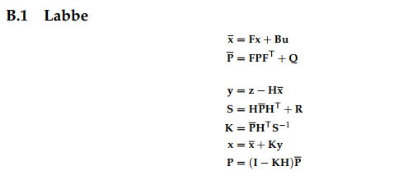 Two and three states formula are the same to Kalman Gain, but for the numerical stability , three states are preferable.
2. There are many notation variances. ”Kalman and Bayesian Filters in Python, 2018”

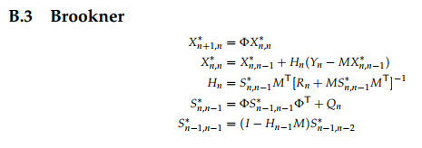

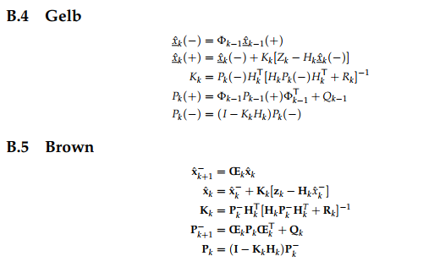

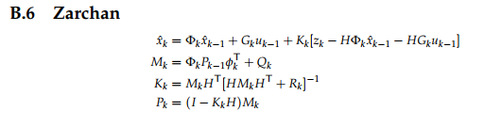

1. In the book of .”Kalman and Bayesian Filters in Python, 2018”, there are many filters as

* Kalman filter
* Unscented Kalman filter
* Extended Kalman filter
* Particle filter
* Ensemble Kalman filter
* “H infinity” filter

So which one is the best? “There is no royal road” It depends on your modeling. After invention computers, the computation power is no limited. So if you image something new algorithm, it may be realizable. These filters are difficult to achieve without “Computer” , Nowadays the estimator is more important not only in control but in data science, machine learning and Artificial Intelligence. there should be “Estimation” to be optimal in the sense.